- Setup a highly available ecs cluster with load balancer and dynamic port mapping.
NOTE:
- Your cluster should maintain atleast 6 tasks at any point of time and should be highly availble across multiple AZ's.
- Use the below image from deployment: sabair0509/hiring-app:works
First pull the image using the command
Docker pull sabair0509/hiiring-app:36
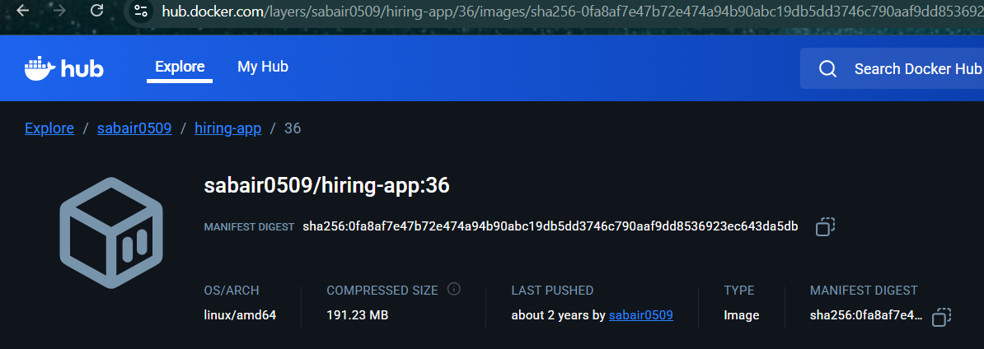
2️⃣ Fix: push the image with latest tag (correct way)
Step — Login to Public ECR
aws ecr-public get-login-password --region us-east-1 \
| docker login --username AWS --password-stdin public.ecr.aws
Step — Tag it EXACTLY like ECS expects
docker tag hirirng-app:latest public.ecr.aws/w0i9j3u1/mohdparvez/hirirng-app:latest
⚠️ Spelling matters
You are using: hirirng-app (not hiring-app)

Step — Push to Public ECR
docker push public.ecr.aws/w0i9j3u1/mohdparvez/hirirng-app:latest

Step — Confirm it works
docker pull public.ecr.aws/w0i9j3u1/mohdparvez/hirirng-app:latest
If this pulls successfully → ECS will work.

Now got to the ECS
Copy your ecr url and paste here
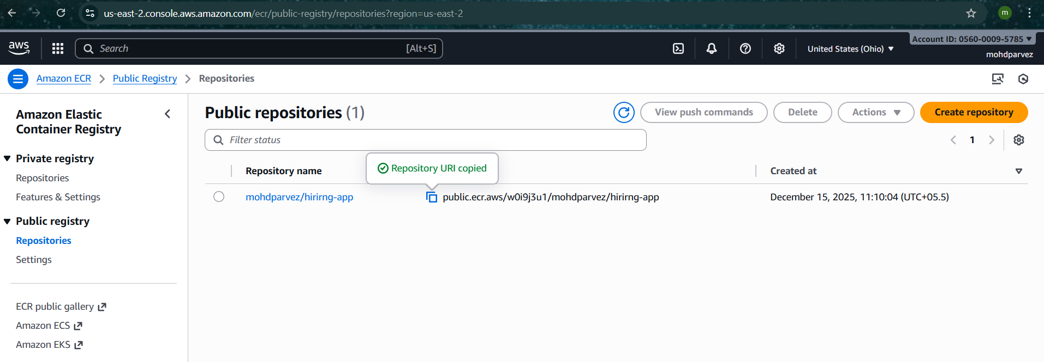
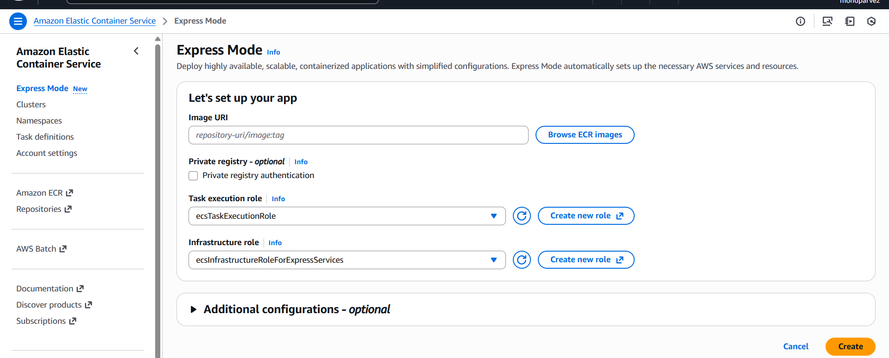
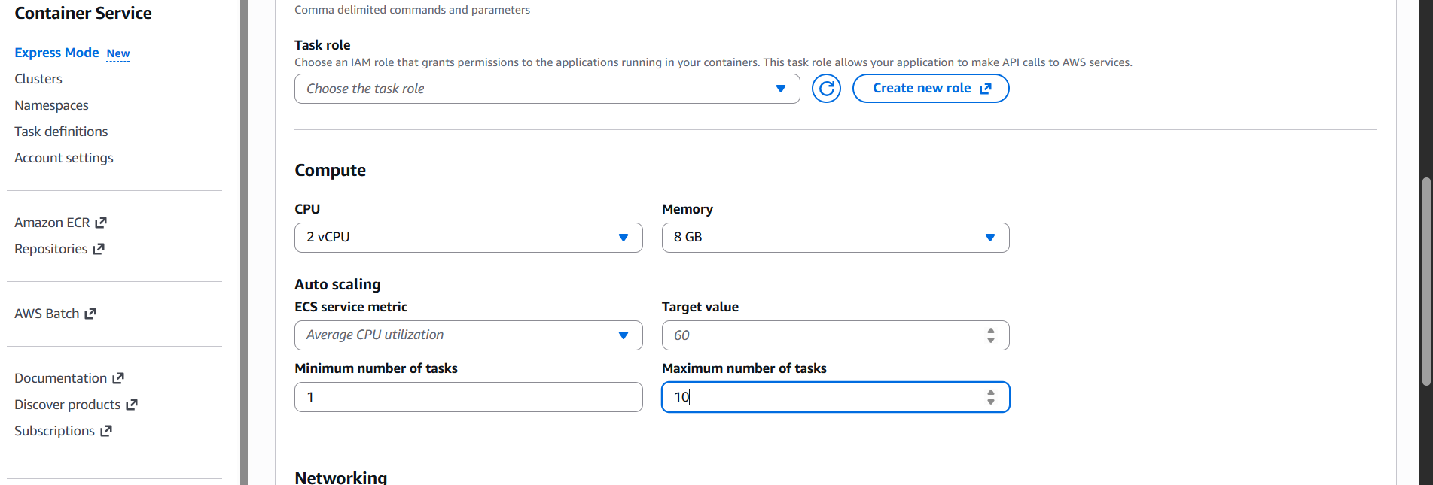
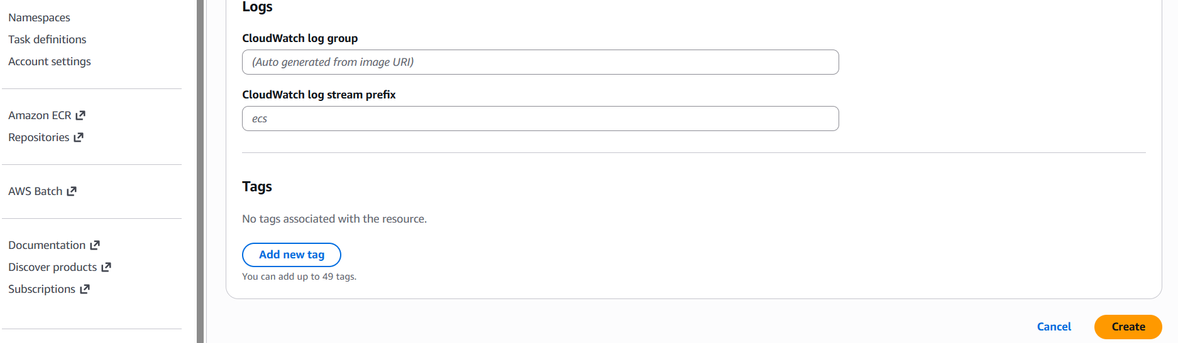

It will automatically creates all the insfrantructure resources like
Resources Info
Your AWS resources for this service. Updates automatically.
Cluster: default
Task definition: default-hirimg-app-8a4f.1 Z
Target service revision: 8096849576161908572
Service security group: sq-05192c2a5fbf1638b
Active
Last updated at December 15, 2025, 16:13 (UTC+5:30).
Log group: /aws/ecs/default/hirirng-app-8a4f-37c5 Z

Active
Last updated at December 15, 2025, 16:13 (UTC+5:30).
Metric alarm: default/hirirng-app-Ba4f/RollbackAlarm
Last updated at December 15, 2025, 16:13 (UTC+5:30).
Public ingress path: hi-2338d24deb354133a1752493265c91f1.ecs.us-east-2.on.aws
Certificate: hi-2338d24deb354133a1752493265c91f1.ecs.us-east-2.on.aws
Active

Last updated at December 15, 2025, 16:13 (UTC:5:30).
Load balancer security group: sq-0d02630c83e9b9bfa

Active

Last updated at December 15, 2025, 16:13 (UTC+5:30)
Load balancer: app/ecs-express-gateway-alb-ecaac249/ed206941ad98898b
Active

Last updated at December 15, 2025, 16:13 (UTC+5:30)
Listener: app/ecs-express-gateway-alb-ecaac249/ed206941ad98898b/6db33cca85ecd01b
Active

Last updated at December 15, 2025, 16:13 (UTC:5:30).
Target group: ecs-gateway-tq-01a9b3da5ced30ebd/c30350bcB5ea476f

Active

Last updated at December 15, 2025, 16:13 (UTC+5:30).
Target group: ecs-gateway-tq-cd0e7b2a419bd6739/b85cc5ee0743c363 Z
Active

Last updated at December 15, 2025, 16:13 (UTC:5:30)
Listener rule: app/ecs-express-gateway-alb-ecaac249/ed206941ad98898b/6db33cca85ecd01b/a14b9a6f1008940b
Active

Last updated at December 15, 2025, 16:13 (UTC+5:30).
Scaling target: service-default-hirirng-app-Ba4f Active
Last updated at December 15, 2025, 16:13 (UTC:5:30).
Scaling policy: hirirng-app-Ba4f
Active
Last updated at December 15, 2025, 16:13 (UTC+5:30).
Service: hirirng-app-Ba4f
Active
service hirimg-app-8a4f ( has reached a steady state.
Deployment bfrfRvL7O5BTM13oGsKyi ( has completed.
Completed at December 15, 2025, 16:16 (UTC+5:30)

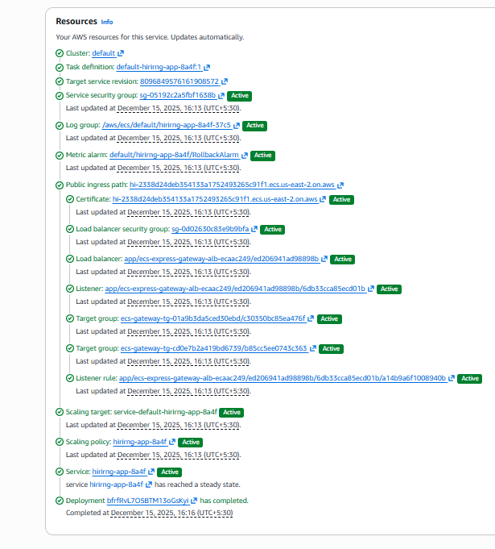
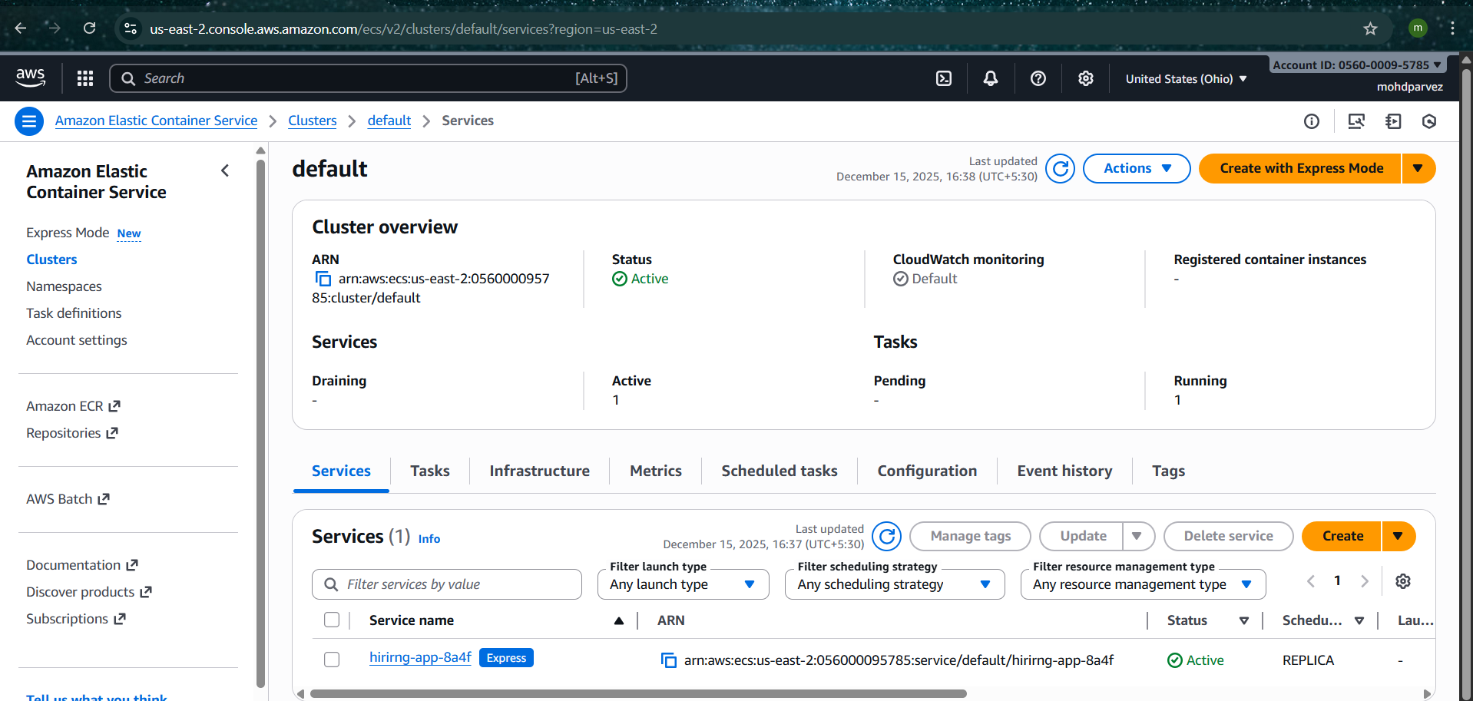

After completion check with the url
